**Four wheel Mecanum Drive**

**What is a mecanum wheel ?**

It is a conventional wheel with a series of rollers attached to its circumference. These rollers typically each have an axis of rotation at 45° to the plane of the wheel and at 45° to a line through the centre of the roller parallel to the axis of rotation of the wheel.

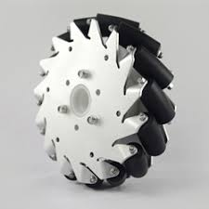

* Analysis of four wheel mecanum drive

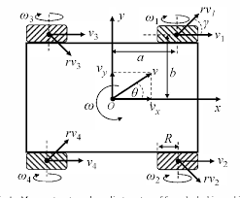

Fig.1

Let us suppose the necessary conditions for the analysis of a four wheel mecanum drive.

“V” be the total translational velocity of the drive with Vx and Vy components in X and Y directions respectively

“ω” be the angular velocity of the drive(robot)

“ai” and “bi” be the robot dimension; i.e, the distance between the centre of the robot and the centre of the wheel

a ={a,a,-a,-a}

b ={b,-b,b,-b}

“Vi” be the linear velocity of ith mecanum wheel (V1,V2,V3,V4)

“rVi“ be the roller velocity of the ith mecanum wheel (rV1,rV2,rV3,rV4)

“γi" be the tilted angle of the roller

γi = {45,-45,-45,45}

* The velocity vector equation can be written as

Vi + rVicos(γi) = Vx – biω [1]

rVisin(γi) = Vy + aiω [2]

Vi = Vx – biω – ((Vy + aiω)/tan(γi)) [3]

tan(γi) = {1,-1,-1,1}

V1 = Vx – Vy – aω –bω [4]

V2 = Vx + Vy + aω +bω [5]

V3 = Vx + Vy – aω – bω [6]

V4 = Vx – Vy +aω+ bω [7]

The equations [4],[5],[6]and [7] can be expressed as matrix equation

 =  [A]

This is inverse kinematics model for a four wheel mecanum drive .